**QA Site Review of New Navigation Treatment**

Steve Gerrard

September 27, 2012

**Overall**

Good progress. This will make a big difference when it is fully implemented. Now that I see it, I think we need to make some changes, as noted below.

**Comments**

I like the shape of the pull-down menu. I like the way the individual entries are highlighted when the mouse rolls over them.

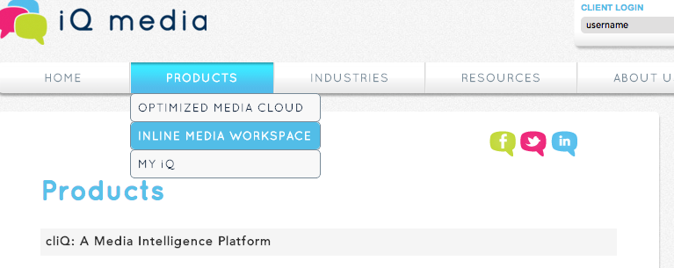

In general, I find the text on the un-highlighted boxes to be illegible. That is, the “I” and “T” and part of the curve of the “Q” appear to be washed out. It looks like a printer that is running out of toner. I think we have this problem on the main nav bar as well, but it is much more pronounced in the sub-menus. It is seen on every sub-menu.

Now that I see the results, I think we need an “OVERVIEW” sub-entry that takes the user to the same place as clicking on “PRODUCTS” – this will make it obvious that there is an overview page with generalized info on it. This is needed in the PRODUCTS and INDUSTRIES sections.

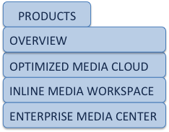

If the user clicks on PRODUCTS or OVERVIEW, it goes

to the same page as clicking on PRODUCTS goes to now.

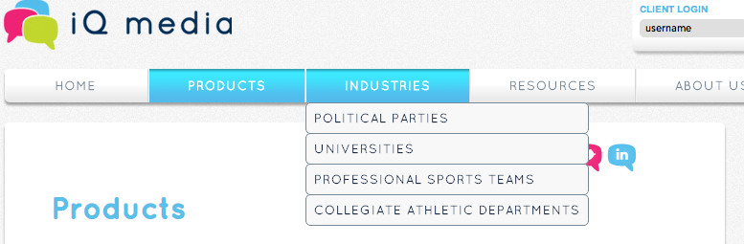

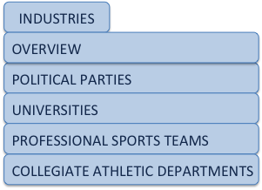

This menu would look like this:

Notice the washed-out letters … I, T, right-  
hand side of the R, etc.

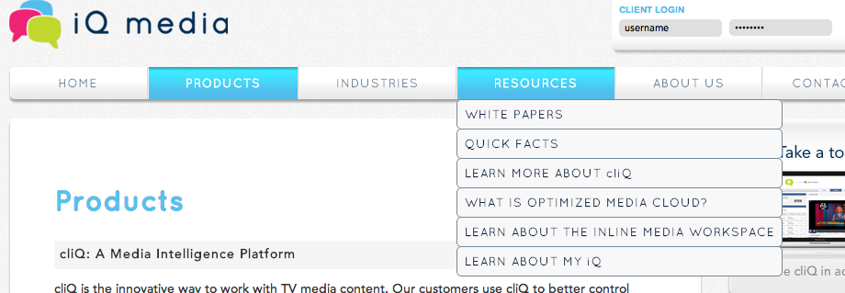

The behavior of this menu is not what I want, but that’s because we have only a few resources now. Clicking on the entries opens up the document – which is not what we want. What I envision are sub-pages that contain the different types of resources that will be on the site.

We should NOT implement any changes to this part of the site until we have a few more items in the RESOURCES section. At that time, the menu should look and operate as follows:

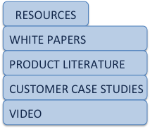

At this future time, clicking on:

* RESOURCES = causes no action
* WHITE PAPERS = takes users to a white papers page on which there are thumbnails and descriptions of the numerous white papers we will have (today we only have one).
* PRODUCT LITERATURE = takes users to a page where we have literature. Today we have 5 documents.
* CASE STUDIES = takes users to a page where we will have case studies. Today we don’t have any case studies.
* VIDEO = takes users to a page where we will have numerous videos on different topics. Today we only have the “Take a Tour” video.

Because we do not have very many resources today, we should leave this section alone and let it operate as it does today. However, in a week or two we will have more resources and at that time we’ll want to implement this functionality.

Please contact me if there are any questions.

SG